**ROUNAK GUPTA(2023UCS1597)**

**COMPUTER PROGRAMMING ASSIGNMENT**

**LIST OF PYTHON PROGRAMS -I**

**1. Write a Function that takes two strings and returns TRUE if they are anagrams**

**and False otherwise. A pair of strings is anagrams if letters in one word can be**

**arranged to form the second one**

**2. Write a Function that takes a list of numbers as input from user and produces**

**the corresponding cumulative list where each element in the list at index I is the**

**sum of elements at index j <= I**

**3. Write a python program that takes a number as input and returns the**

**corresponding text in words. Use dictionary for mapping digits to their string**

**representation**

**4. Write a program that takes a sentence as input from the user and computes the**

**frequency of each letter. Use a variable of dictionary type to maintain the count**

**5. Write a recursive function that multiplies two positive numbers a and b and**

**returns the result. Multiplication is to be achieved as a+a+a (b time)**

**6. Write a function to reverse a string using recursion**

Q1.

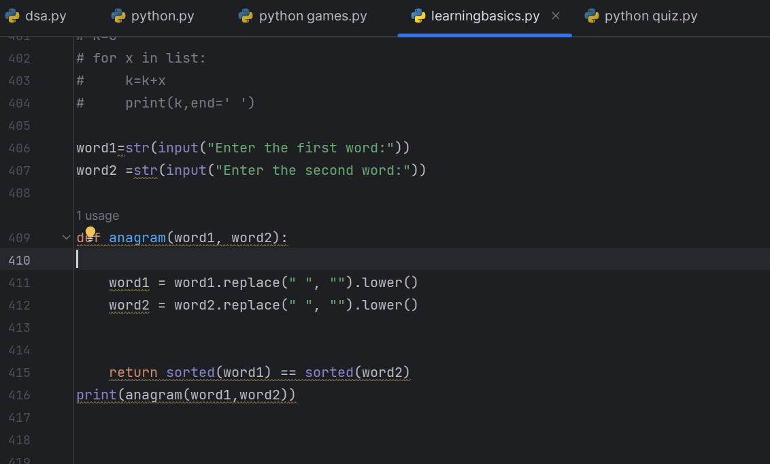

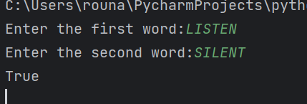

Q2.

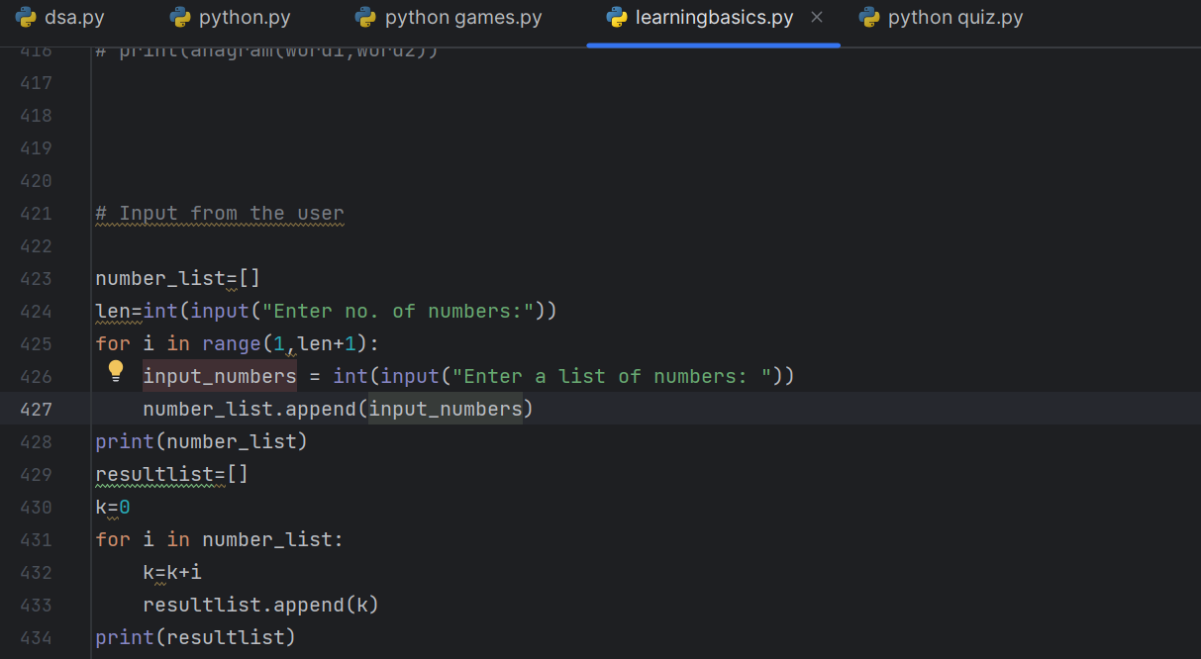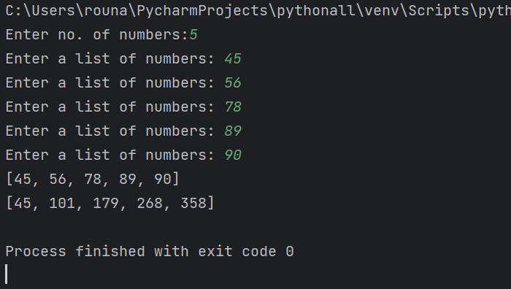

Q3.

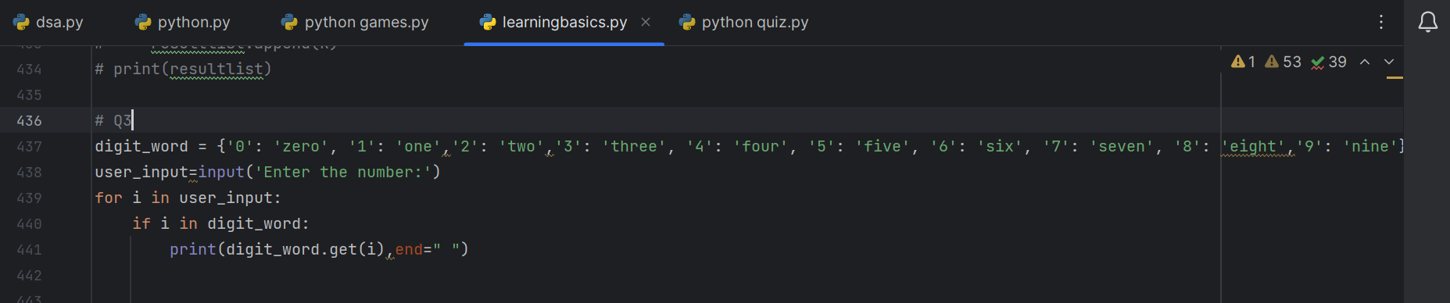

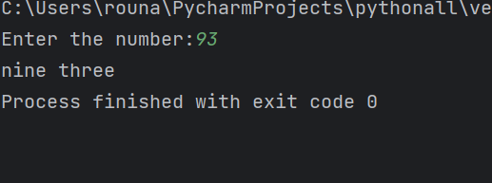

Q4.

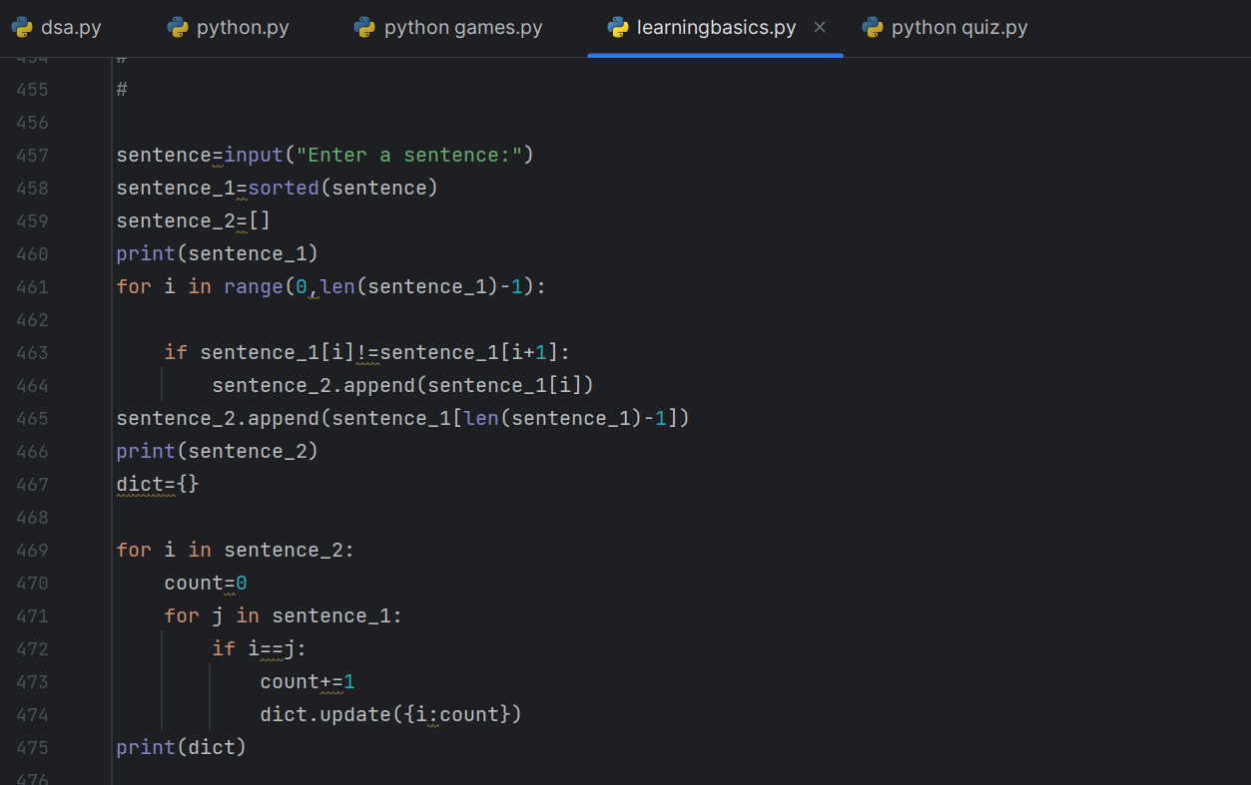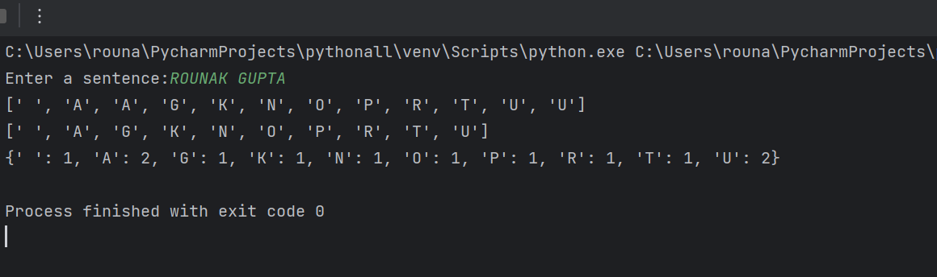

Q5.

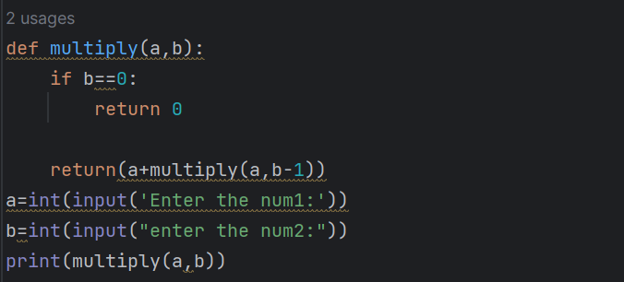

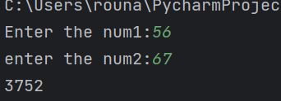

Q6.

